REQUEST FOR MUNICIPAL ADVISOR

STATEMENT OF QUALIFICATIONS

OVERVIEW
The STO requests a Statement of Qualifications (SOQs) from firms interested in providing municipal advisor and related services. Selected firms who respond and are approved will be admitted to the STO’s Municipal Advisor Pool (Pool), which will be established on May 1, 2023, and may be appointed to serve as a municipal advisor for bonds, notes, and other debt obligations issued by the State of California (State), State Public Works Board, other State agencies, and State conduit financing authorities.

Specific appointments may be made directly from Pool members in good standing, or upon submission of responses to a supplemental request for qualifications (RFQ). Municipal advisors to conduit borrowers typically are not required to be members of the Pool. Municipal advisors to State conduit financing authorities chaired by the Treasurer must be members of the Pool.

BONDS AND NOTES ISSUED BY THE STATE OF CALIFORNIA AND OTHER STATE AGENCIES

General Obligation (GO) Bonds and Commercial Paper (CP)
The issuance of GO bonds, including Veteran’s GO Bonds, is authorized by California voter approved bond acts (bond acts), the State General Obligation Bond Law in Chapter 4 (commencing with Section 16720) of Part 3 of Division 4 of Title 2 of the California Government Code, and the related resolutions approved by the applicable finance committees created under the bond acts. GO bonds may be issued to finance various projects under the respective bond acts, refund outstanding GO bonds, or refund CP. CP may be issued to fund on an interim basis initial project costs under the respective bond acts until long term bonds are issued.

Revenue Anticipation Notes (RANs)
In accordance with Government Code Section 17300 et. seq., the State issues RANs, from time to time, to meet its short-term cash management needs. RANs are secured by any unapplied monies in the General Fund and must be repaid by the end of the fiscal year in which it was issued. The State has not issued RANs since fiscal year 2014-15.

State Public Works Board (SPWB)
Through the SPWB the State acquires and constructs certain capital facilities through the issuance of lease revenue obligations. The SPWB issues lease revenue bonds to finance or refinance the costs of the acquisition and construction of various facilities including correctional facilities, court facilities and office buildings. The State Legislature must authorize all projects through a budget act appropriation or separate legislation. These facilities are leased to a State agency under a long-term lease, which provides the source of revenues which are pledged to the payment of debt service payment for the bonds.

Special Bond Issues
Occasionally, the State will issue debt by securitizing streams of revenues via a special bond issue, which are payable from anticipated reimbursements, revenues or payments such as the Tobacco Settlement Asset-Backed Bonds or the Federal Highway Grant Anticipation (GARVEE) Bonds.

STATE CONDUIT FINANCING AUTHORITIES CHAIRED BY THE TREASURER THAT REQUIRE MUNICIPAL ADVISORS THAT ADVISE THE AUTHORITY TO BE MEMBERS OF THE POOL:

California Alternative Energy and Advanced Transportation Financing Authority (CAEATFA)
http://www.treasurer.ca.gov/caeatfa/index.asp

California Educational Facilities Authority (CEFA)
http://www.treasurer.ca.gov/cefa/index.asp

California Health Facilities Financing Authority (CHFFA)
http://www.treasurer.ca.gov/chffa/index.asp

California Pollution Control Financing Authority (CPCFA)
http://www.treasurer.ca.gov/cpcfa/index.asp

California School Finance Authority (CSFA)
http://www.treasurer.ca.gov/csfa/index.asp

California Transportation Financing Authority (CTFA)
https://www.treasurer.ca.gov/ctfa/index.asp
Please note, municipal advisors hired by conduit borrowers are generally not required to be a member of the Pool.

SCOPE OF SERVICES

MUNICIPAL ADVISOR
The scope of services may include, but not be limited to, the following:

Assist with the development of financing plans;

Advise on the merits of competitive, negotiated, or private placement of debt;

Participate in bond document review sessions. Review and comment on the preliminary and final official statements, and participate in due diligence meetings;

Review and comment on proposed underwriting syndicate policies and compensation, provide advice on approach to establishing issue price for tax-exempt financings;

Review and comment on the proposed marketing plan submitted by the underwriting syndicate, review and comment on any proposed investor presentation;

Analyze the cost benefit of different structuring and pricing options. This may include, but is not limited to, fixed rate versus variable rate bonds, insured versus uninsured bonds, callable versus non-callable bonds, and par versus discount or premium bonds;

Participate in all pricing discussions. Provide data on market comparables and different indices that can be used in pricing discussions. Provide independent price guidance for each maturity across a range of couponing alternatives. Analyze and recommend fair pricing levels based on historical pricings and the pricing of comparable credits in the then current municipal bond market;

Upon request, provide input on the cost of alternative redemption or call features;

Analyze and recommend approaches for structuring refunding escrows, including the evaluation of escrow cost, sufficiency, escrow requirements, and evaluation of investment options for the escrow including the purchase of State & Local Government Securities (SLGS) and/or open-market securities;

If requested, assist in reviewing the proposed allocation of the bonds;

For transactions to be sold on a competitive basis, assist in the preparation of the notice of sale and bidding specifications, including the basis for award, bond amortization, and electronic bidding logistics. Independently evaluate and verify bids, including verification of the True Interest Cost (TIC) calculations and conformance with bidding parameters;

For sealed bid proposals within a negotiated sale, assist in the preparation of bidding provisions, independently evaluate and verify bids, verify calculations and conformance with bidding parameters, independently rank submitted bids, and recommend an award;

Solicit proposals from qualified firms to provide escrow verification services, summarize proposals received, and assist in the review of the verification report when submitted;

Participate in a post-financing review as requested. At a minimum, this work will include preparation of a memorandum that addresses how the State’s bonds priced relative to market indices, comparables, and any goals established prior to sale as part of an agreed upon marketing plan;

Analyze any proposals for new products as they pertain to the particular financing;

Assist with rating agency or investor meetings, as requested;

Review and report on the feasibility of potential refunding of outstanding bonds;

Provide training to STO and other State agencies as requested; and

Provide additional services as needed from time to time including, but not limited to, special projects.

MINIMUM QUALIFICATIONS

In order to be eligible for admission to the Pool, all firms must meet the following minimum qualifications:

PUBLIC FINANCE EXPERIENCE
The firm or its advisors designated to work on State or State conduit authority financing programs, must have a minimum of three years of public finance experience, which may include municipal advisor experience or investment banking experience.

REGISTRATION
The firm must be registered as a Municipal Advisor with both the Municipal Securities Rulemaking Board and Securities and Exchange Commission.

LEGAL DISCLOSURE
The firm has not disclosed any matters on Attachment E. Registration, Disciplinary Action, and Litigation, which would preclude participation in the Pool as determined by the STO.

BOND CAMPAIGN CONTRIBUTION AND SERVICES PROHIBITION CERTIFICATION
Firms applying to the Pool must certify that the firm has in place a policy or procedure requiring that the firm or any municipal finance professional associated with the firm will not accept any municipal securities business with a municipal entity in California within two years of any contribution made or provided by the firm or any municipal finance professional associated with the firm to a bond ballot campaign for bonds of the municipal entity (Bond Campaign Contribution and Services Prohibition Policy).

Please see Attachments F for defined terms associated with this minimum qualification.

QUARTERLY DISCLOSURE REPORT
Firms selected as members of the Pool are required to update the STO quarterly regarding any changes to the firm’s ability to meet the minimum qualifications, including but not limited to updates to the legal disclosure information submitted in the firm’s SOQ and changes to personnel working with the STO. If a firm fails to submit the mandatory quarterly report within one week of the deadline (April 30, July 31, October 31, and January 31), the firm may be ineligible for appointments and/or suspended from the Pool.

PROFESSIONAL LIABILITY INSURANCE
The firm must maintain adequate professional liability (errors and omissions) insurance coverage with either a securities transaction rider or coverage without exclusion for securities transactions.

CALIFORNIA TAXPAYER AND SHAREHOLDER PROTECTION ACT OF 2003–U.S. EXPATRIATE CORPORATIONS (PUBLIC CONTRACT CODE SECTIONS 10286 AND 10286.1)
The STO will not contract or otherwise do business, absent a compelling public interest, with publicly held U.S. expatriate corporations. This law is designed to ensure that companies the STO conducts business with meet threshold standards of corporate accountability.

DARFUR CONTRACTING ACT OF 2008
The firm must comply with the Darfur Contracting Act of 2008. The Act was passed by the California Legislature and signed into law by the Governor to preclude State agencies generally from contracting with “scrutinized” companies that do business in the African nation of Sudan (of which the Darfur region is a part), for the reasons described in Public Contract Code section 10475. A scrutinized company is a company doing business in Sudan as defined in Public Contract Code section 10476.

Scrutinized companies are ineligible to, and cannot bid on, or submit a proposal for a contract with a state agency for goods or services. [Public Contract Code section 10477(a)]. Therefore, Public Contract Code section 10478 (a) requires a company that currently has, or within the previous three years has had, business activities or other operations outside of the United States to certify that it is not a “scrutinized” company when it submits a bid or proposal to a State agency. A scrutinized company may still, however, submit a bid or proposal for a contract with a State agency for goods or services if the company first obtains permission from the Department of General Services (DGS), according to the criteria set forth in Public Contract Code section 10477(b).

ECONOMIC SANCTIONS
On March 4, 2022, Governor Gavin Newsom issued Executive Order N-6-22 regarding Economic Sanctions against Russia and Russian entities and individuals. “Economic Sanctions” refers to sanctions imposed by the U.S. government in response to Russia’s actions in Ukraine. Firms applying to the Pool must certify that they are not a target of Economic Sanctions or conducting prohibited transactions with sanctioned individuals or entities. Failure to comply may result in removal from the pool, at the sole discretion of the STO.

IRAN CONTRACTING ACT OF 2010
Once appointed to a transaction, the firm must comply with the Iran Contracting Act of 2010. The Act requires that, at the time a firm is selected for any appointment in which the firm can reasonably be expected to earn $1,000,000 or more from the sale, the firm will be required to: a) certify it is not on the current list of persons engaged in investment activities in Iran created by the DGS pursuant to Public Contract Code Section 2203(b) and is not a financial institution extending twenty million dollars ($20,000,000) or more in credit to another person, for 45 days or more, if that other person will use the credit to provide goods or services in the energy sector in Iran and is identified on the current list of persons engaged in investment activities in Iran created by DGS; or b) demonstrate it has been exempted from the certification requirement for that solicitation or contract pursuant to Public Contract Code Section 2203(c) or (d). Please note, if a firm claims the Section 2203(c) or (d) exemption, additional findings by the STO are required and will be made solely at the discretion of the STO.

With respect to any applicable bond transaction for one of the State’s conduit financing authorities, the required certification shall be made prior to the authority’s approval of a final resolution authorizing the issuance of bonds.

TAX DELINQUENCIES CONTRACT BAN
Public Contracting Code Section 10295.4 prohibits a State agency from entering into any contract for services with a contractor whose name appears on either the list of the 500 largest tax delinquencies produced by the Franchise Tax Board (FTB) (https://www.ftb.ca.gov/about-ftb/newsroom/top-500-past-due-balances/index.html) or the California Department of Tax and Fee Administration (CDTFA) (https://www.cdtfa.ca.gov/taxes-and-fees/top500.html).

Accordingly, the STO will check FTB and CDTFA lists to ensure proposed pool members are not on either list.

CIVIL RIGHTS CERTIFICATIONS
Once appointed to a transaction, the firm must comply with the Civil Rights Certifications (Public Contract Code Section 2010) which requires that a contractor (and its subcontractors) shall not deny the contract’s benefits to any person on the basis of race, religious creed, color, national origin, ancestry, physical disability, mental disability, medical condition, genetic information, marital status, sex, gender, gender identity, gender expression, age, sexual orientation, or military and veteran status, nor shall they discriminate unlawfully against any employee or applicant for employment because of race, religious creed, color, national origin, ancestry, physical disability, mental disability, medical condition, genetic information, marital status, sex, gender, gender identity, gender expression, age, sexual orientation, or military and veteran status. In addition, a contractor shall ensure that the evaluation and treatment of employees and applicants for employment are free of such discrimination. A contractor shall comply with the provisions of the Fair Employment and Housing Act (Government Code Section 12900 et seq.), the regulations promulgated thereunder (California Code Regulations, Title 2, Section 11000 et seq.), the provisions of Article 9.5, Chapter 1, Part 1, Division 3, Title 2 of the Government Code (Government Code Section 11135-11139.5), and the regulations or standards adopted by the awarding state agency to implement such article. A contractor shall permit access by representatives of the Department of Fair Employment and Housing and the awarding state agency upon reasonable notice at any time during the normal business hours, but in no case less than 24 hours’ notice, to such of its books, records, accounts, and all other sources of information and its facilities as said Department or Agency shall require to ascertain compliance with this clause. A contractor shall give written notice of their obligations under this clause to labor organizations with which they have a collective bargaining or other agreement. (See California Code of Regulations, Title 2, Section 11105.)

CONTENT OF STATEMENT OF QUALIFICATIONS
Responses should be limited to 15 pages (excluding attachments and appendices) using a typeface font of no less than 12 pitch. Please answer all questions carefully. If a question does not apply to the firm or circumstances, please respond "N/A." Failure to respond to all questions and provide all requested information or deviation from the required format will delay the processing of the firm’s SOQ and may result in disqualification. Please address the following items in responding to this RFQ:

COVER LETTER
Cover letter shall be signed by a person authorized to commit the firm to the terms of the response and is primarily responsible for the veracity of statements made in the response.

FIRM ATTRIBUTES AND COMMITMENT TO CALIFORNIA

Provide a brief history, description, and ownership structure of the firm. State the length of time the firm has been in business under its current name as well as any previous names. Also, state whether the firm solely provides municipal advisor services or whether it is also a broker-dealer.

Briefly list all significant lines of business, beside public finance, in which the firm, its parent company or subsidiary is active.

How many full-time employees does the firm currently employ nationwide and in California? Provide a table showing the total number of Municipal Advisors working in both California and outside of California. What was the percentage of worldwide compensation (including distributions to partners) paid to California residents in the past year?

How many offices does the firm have in California? Has the firm opened or closed offices in California or otherwise changed its commitment to California within the last five years?

Where is the firm’s headquarters located?

Does your firm have a formal measurement system for measuring diversity and inclusion at the senior management level? Yes or No. Please provide the following data for your top twenty employees, based on Box 5 income reported on IRS Form W-2 (if your firm employs 500 or more persons, full-time); or, your top ten employees (if your firm employs fewer than 500 employees, full-time):

Percent of those employees identifying themselves as ethnically non-white; and,

Percent of those employees identified as female

PUBLIC FINANCE EXPERIENCE AND CAPABILITIES

Describe the qualifications and experience that demonstrate the firm’s capability in providing the services described in Section II. SCOPE OF SERVICES.

Describe the firm's experience serving as municipal advisor for taxable and tax-exempt obligations issued by the State, State agencies, State conduit financing authorities, and local California issuers since January 1, 2019. List in Attachment A the name of the issuer, the name of the issue, sale date, par amount, type of issue, method of sale, and the firm’s role in the transaction (e.g., pricing advisor, municipal advisor, co-municipal advisor).

Describe the firm's experience serving as municipal advisor for taxable and tax-exempt obligations issued by issuers outside of California since January 1, 2019. List in Attachment B the name of the issuer, the name of the issue, sale date, par amount, type of issue, method of sale, and the firm’s role in the transaction (e.g., pricing advisor, municipal advisor, co-municipal advisor).

Describe the firm’s access to sources of current market information to assist in pricing negotiated sales and information to assist in the planning and execution of competitive sales.

Provide a brief description of the firm’s experience on a debt issuance in which you recommended an innovative or unique financing idea that benefited the issuer.

Describe the firm’s experience serving as municipal advisor for variable rate obligations issued or administered by a State, State agency, State conduit financing authority, or local issuer.

Identify the types of municipal debt in which the firm has particular expertise.

Provide a short narrative describing the firm’s technical and analytical expertise, including a summary of how the firm handles complex cash flow modeling. Provide, as an appendix, one case study that best illustrates the firm's capabilities to model the most complex scenarios.

Is the firm a registered investment advisor? If so, please include on Attachment E, Registration, Disciplinary Action, and Litigation, evidence of such registration.

Provide, as an appendix, at least two samples of your firm’s written work. (The response to this question will not count against the page limit.)

PERSONNEL

Please complete Attachment C regarding the personnel assigned to work on financings for the State, State agencies, and State conduit financing authorities. In addition, please complete Attachment D listing contact information for the relevant personnel.

Describe the firm’s continuing education policies and internal training programs.

Describe the firm’s procedures for supervising the work of its Municipal Advisors. Are the procedures written? How is compliance with such procedures verified? How often?

Were any of the firm’s employees associated with a broker-dealer firm within the past two years?

COMPLIANCE WITH MINIMUM QUALIFICATIONS

Public Finance Experience: Describe how the firm meets the requirement described in Section III.A.1 PUBLIC FINANCE EXPERIENCE.

Registration & Legal Disclosure: Please complete Attachment E.

Bond Campaign Contribution and Services Prohibition Certification: Please complete Attachment F.

Professional Liability Insurance: Please attach, as an appendix, evidence of professional liability insurance coverage for the firm and its advisors including coverage amounts. The evidence of coverage should indicate whether securities transactions are covered. Evidence of coverage will need to be provided annually.

California Taxpayer and Shareholder Protection Act of 2003 – U.S. Expatriate Corporations: Please complete Attachment G.

Darfur Contracting Act of 2008: Please complete Attachment H.

Economic Sanctions Certificate: Please complete Attachment I.

Iran Contracting Act of 2010: Once appointed for an engagement, firms may be required to complete a certification similar to Attachment J.
Please note that Attachment J is for your information only and does not need to be completed as part of the SOQ.

Civil Rights Certification: Once appointed for an engagement, firms will be required to complete a certification similar to Attachment K.
Please note that Attachment K is for your information only and does not need to be completed as part of the SOQ.

CONFLICTS OF INTEREST

Describe any finder’s fees, fee splitting, payments to consultants, or other contractual arrangements of the firm that could present a perceived, possible, or real conflict of interest.

Describe any other perceived, possible, or real conflict of interest arising from your relationships with or representation of other parties.

Describe any major concentrations of the firm’s business among broker-dealer firms. For example, does a single broker-dealer firm account for more than 20% of the number of negotiated sales the firm advises? Please provide a list of such firms and explain the relationship.

Describe how your firm handles and discloses to clients the inherent conflicts in contingent fee arrangements.

Does the firm provide in-kind services to any clients in lieu of other financial compensation, this includes polling and election based services? Please describe.

DISABLED VETERAN BUSINESS ENTERPRISE
State law establishes participation goals of three percent for Disabled Veteran Business Enterprises (DVBEs) in contracts for professional bond services awarded by State agencies. These goals apply to the annual dollar amount expended on professional bond services, including municipal advisor fees.

Firms requesting DVBE status must submit their California DVBE Certificate as an appendix to the firm’s SOQ and resubmit annually as the DVBE Certificate is renewed. DVBE certification may be obtained through the DGS.
https://www.dgs.ca.gov/PD/Services/Page-Content/Procurement-Division-Services-List-Folder/Certify-or-Re-apply-as-Small-Business-Disabled-Veteran-Business-Enterprise

MINORITY OR WOMEN BUSINESS ENTERPRISES (MWBEs)
Although State law prohibits the use of participation goals for Minority Business Enterprises (MBEs) or Women Business Enterprises (WBEs) (California Constitution Article I, Section 31), it does require the STO to report annually to the Governor and the Legislature on the level of participation by MBEs and WBEs in contracts for professional bond services awarded (Government Code Section 16855). The STO requests firms disclose this information, on a voluntary basis, by completing Attachment L. The STO uses this information for reporting purposes only and not for the purpose of municipal advisor appointments.

DELIVERY
The STO may reject any incomplete SOQs. For your reference, an SOQ checklist is located on page 15. The STO will accept SOQs by e-mail only. Please include your firm’s name in the subject field:

E-MAIL DELIVERIES:

Address:

To: InvestorRelations@treasurer.ca.gov

Subject: FIRM NAME-Municipal Advisor Statement of Qualifications

Electronic deliveries must be in Adobe Acrobat PDF format.

If you have any questions, please contact Geoff Palmertree at gpalmertree@treasurer.ca.gov or (916) 653-2440

FEES
Fees will be established at the time appointment to a particular sale or program.

CALIFORNIA PUBLIC RECORDS ACT
All material submitted in response to this solicitation will become the property of the State and will not be returned. In addition, all material submitted may be considered a public record by the STO and subject to disclosure pursuant to the California Public Records Act (Government Code Section 7920.000 et seq.).

STATEMENT EVALUATIONS
SOQ’s will be evaluated based on the following criteria (not listed in order of importance):

- Satisfaction of the minimum qualifications;
- Qualifications and experience of firm and personnel named in the SOQ;
- Capability to provide required services; and
- Past experience on State, State agency, and State conduit financing authority debt financings, as well as other municipal debt financings.
The STO reserves the right to:

Request additional information from any firm prior to its selection;

Select firms that will best meet the STO’s needs; or
- Consider information about any firm from other sources in addition to the information submitted by the firm.
The STO may from time to time seek ideas, advice, and proposals from Pool members. Neither inclusion in the Pool nor providing ideas, advice, and proposals offers any assurance that any firm will be selected to provide municipal advisor services.

REMOVAL FROM AND ADDITIONS TO THE POOL
Any firm may be removed or suspended from the Pool for reasons that include, but are not limited to, the following:

- Disqualification due to legal proceedings outlined on Attachment E, including actions, settlements or judgments, disciplinary actions by state or federal regulatory agencies, criminal indictments or convictions, and claims of fraud whether criminal or civil;
- Unacceptable performance on any bond sale or project as determined by an evaluation completed by the STO’s Public Finance Division or a State conduit financing authority;
- Failure to comply with STO policies;
- Being the subject of disciplinary action by state or federal regulatory agencies;
- Filing for protection under federal or state bankruptcy laws;
- Failure to continue to meet the minimum qualifications listed under Section III. MINIMUM QUALIFICATIONS;
- Failure to submit quarterly disclosure reports in a timely manner; or
- Failure to respond to reasonable information requests.
The STO accepts Pool applications on an ongoing basis. Pool applicants will be required to submit a response to the Request for Municipal Advisor Statements of Qualifications and will be evaluated based on the same criteria used to establish the Pool.

ONGOING COMPLIANCE WITH MINIMUM QUALIFICATIONS
To remain in the Pool and eligible for appointments, firms must meet Section III. MINIMUM QUALIFICATIONS, at all times. Pool members are responsible notifying the STO's Public Finance Division Director within 10 days if the firm no longer meets the minimum qualifications.

In addition, if the firm is currently appointed to a bond sale or project and subsequently no longer meets the minimum qualifications the firm must immediately contact the STO's Public Finance Division Director.

Statement of Qualifications Checklist
State of California
Office of the State Treasurer

The STO requires the following information when submitting a complete statement of qualifications, incomplete statement of qualifications will be returned:

Content
☐ | Section IV.A. Cover Letter
☐ | Section IV.B. Firm Attributes and Commitment to California Questions 1-6
☐ | Section IV.C. Public Finance Experience and Capabilities Questions 1-10
☐ | Section IV.D. Personnel Questions 2-4
☐ | Section IV.E.1. Public Finance Experience
☐ | Section IV.E.5. Professional Liability Insurance: Please provide evidence of the firm’s professional liability insurance coverage for the firm and its advisors including coverage amounts AND indicating that securities transactions are covered.
☐ | Section IV.E. Conflicts of Interest Questions 1-5

Attachments
☐ | Attachment A: Public Finance Experience-California Issuers
☐ | Attachment B: Public Finance Experience-Issuers Outside of California
☐ | Attachment C: Personnel Experience, including a resume for each individual
☐ | Attachment D: Firm Contacts
☐ | Attachment E: Registration, Disciplinary Action, and Litigation
☐ | Attachment F: Bond Campaign Contribution and Services Prohibition Certification
☐ | Attachment G: Expatriate Corporations Certification
☐ | Attachment H: Darfur Contracting Act Certification
☐ | Attachment I: Economic Sanctions Against Russia Certification
☐ | Attachment J: DO NOT COMPLETE - INFORMATIONAL ONLY
☐ | Attachment K: DO NOT COMPLETE - INFORMATIONAL ONLY
☐ | Attachment L: Minority Business Enterprise and Women’s Business Enterprise Certification (Voluntary)

Additional Documentation
☐ | Section IV.C.10. Please include at least two samples of the firm’s written work.
☐ | Section IV.G. Disabled Veteran Business Enterprise: If applicable, please provide certification from the California Department of General Services.

Attachment A

PUBLIC FINANCE EXPERIENCE – CALIFORNIA ISSUERS
State of California
Office of the State Treasurer

As described in Section IV.C.2., please provide the firm’s experience serving as municipal advisor for taxable and tax-exempt obligations issued by the State, State agencies, State conduit financing authorities, and local California issuers since January 1, 2019. List the name of the issuer, the name of the issue, sale date, par amount, type of issue, method of sale, and the firm’s role in the transaction (e.g., municipal or co-municipal advisor).

Please provide the information in this format:

California Issuers
Issuer | Name of Issue | Sale Date | Par  Amount | Type of Issue | Method of Sale | Firm’s Role

Attachment B

PUBLIC FINANCE EXPERIENCE – ISSUERS OUTSIDE OF CALIFORNIA
State of California
Office of the State Treasurer

As described in Section IV.C.3., please provide the firm’s experience serving as municipal advisor for taxable and tax-exempt obligations issued by the State, State agencies, State conduit financing authorities, and local California issuers since January 1, 2019. List the name of the issuer, the name of the issue, sale date, par amount, type of issue, method of sale, and the firm’s role in the transaction (e.g., municipal or co-municipal advisor).

Please provide the information in this format:

Issuers Outside of California
Issuer | Name of Issuer | Sale Date | Par  Amount | Type of Issue | Method of Sale | Firm’s Role

Attachment C
PERSONNEL EXPERIENCE
State of California
Office of the State Treasurer

Identify key personnel (include partners, principals, and associates) who would be directly involved in bond transactions.

Firm Personnel
Name | Title | Office Location | Role | How Long in Current Position? | How Long Employed at Current Firm? | How Long in Municipal Finance Practice?

Please attach a full and complete resume for each individual listed above.

Attachment D
FIRM CONTACTS
State of California
Office of the State Treasurer

Primary Contact with State Treasurer’s Office |  |  | Secondary Contact with State Treasurer’s Office
Name: |  |  | Name:
Title: |  |  | Title:
Address: |  |  | Address:
City/State/Zip: |  |  | City/State/Zip:
Phone: |  |  | Phone:
Email Address: |  |  | Email Address:
Contact to receive all RFQs |  |  | Quantitative Analyst (or comparable position)
Name: |  |  | Name:
Title: |  |  | Title:
Address: |  |  | Address:
City/State/Zip: |  |  | City/State/Zip:
Phone: |  |  | Phone:
Email Address: |  |  | Email Address:
Managing Director (or comparable position) |  |  | Head of Public Finance (or comparable position)
Name: |  |  | Name:
Title: |  |  | Title:
Address: |  |  | Address:
City/State/Zip: |  |  | City/State/Zip:
Phone: |  |  | Phone:
Email Address: |  |  | Email Address:

Attachment E

REGISTRATION, DISCIPLINARY ACTION, AND LITIGATION
State of California
Office of the State Treasurer

REGISTRATION
Please provide each of the following:
Firm’s MSRB Number:
Firm’s Municipal Advisor Registration Number (SEC):
OPTIONAL: Is your firm registered with the Securities and Exchange Commission and/or by the Department of Corporations as an Investment Advisor (NASD Series 65), please provide your firm’s IARD/CRD number:

DISIPLINARY ACTION & LITIGATION
 | Yes | No
- Are there any criminal indictments or convictions brought against the firm or its employees within the past ten years where the charges involved an offering of municipal securities? If yes, please describe in detail each such indictment or conviction. | ☐ | ☐
- Are there now any pending legal actions alleging violations of law in connection with an offering of municipal securities in a California transaction against the firm or any employee of the firm? If yes, please describe each such pending action on a separate attachment. | ☐ | ☐
- Have there been any settlements or judgments involving such actions within the last three years? If yes, please describe each such settlement or judgment, including the nature of the action and the amount of recovery on a separate attachment. | ☐ | ☐
- Are there any pending legal or disciplinary matters involving such actions against the firm by any state or federal regulatory agency? If yes, please describe each action on a separate attachment. | ☐ | ☐
- Are there any material pending legal actions, settlements, or judgments involving a claim of fraud, whether civil or criminal? If yes, please describe in detail each pending action, including the nature of the action and the potential liability of the firm or its employees. | ☐ | ☐

Attachment F

BOND CAMPAIGN CONTRIBUTION AND SERVICES PROHIBITION
MUNICIPAL ADVISOR CERTIFICATION
State of California
Office of the State Treasurer

1. I certify that, ENTER FIRM NAME has in place a policy or procedure requiring that ENTER FIRM NAME or any municipal advisor professional* associated with ENTER FIRM NAME will not accept any municipal securities business with a municipal entity in California within two years of any contribution** made or provided by ENTER FIRM NAME or any municipal advisor professional associated with ENTER FIRM NAME to a bond ballot campaign for bonds of the municipal entity.

2. I understand that ongoing compliance is a minimum qualification for the Municipal Advisor Pool, and failure to maintain this policy or procedure, or a violation of such policy or procedure may result in the firm being removed from the Municipal Advisor Pool.

3. I certify that I am authorized to sign this certification on behalf of ENTER FIRM NAME.

ENTER DATE
Date |  | Signature
 |  | ENTER NAME
 |  | Printed Name
 |  | ENTER JOB TITLE
 |  | Job Title

* The following terms shall be defined as provided in Rule G-37 issued by the Municipal Securities Rulemaking Board: (1) municipal advisor professional; (2) bond ballot campaign; (3) municipal securities business; (4) municipal entity. However, in addition to the G-37 definition of municipal securities business, this certification also applies to competitive sales.

** “Contribution” includes contributions of cash or in-kind services or the provision of bond campaign services either directly or indirectly through or by any other person or means, but does not include a contribution made in an election in which the municipal advisor professional is entitled to vote and the contributions, in total, are not in excess of $250. Bond campaign services includes, but is not limited to, fundraising, public opinion polling, election strategy and management, organization of campaign volunteers, get out the vote services, development of campaign literature, and advocacy materials. Bond campaign services does not include either of the following: (1) advice and support related to the preparation of the bond measure, tax rate statements and other documentation required for board approval; or (2) public opinion polling, or other pre-election services including legal services, that are for purposes of gathering information regarding, and evaluating the potential for, the adoption of the bond measure by the electorate before any action by the governing body to place the measure before the electorate.

Attachment G

EXPATRIATE CORPORATION CERTIFICATION
California Taxpayer and Shareholder Protection Act of 2003
(Public Contract Code Sections 10286 and 10286.1)
State of California
Office of the State Treasurer

California Public Contract Code Section 10286.1, generally provides that a State agency may not enter into any contract with an expatriate corporation or its subsidiaries unless the State Treasurer's Office waives, in writing, the prohibition against contracting with such an entity upon a finding that the contract is necessary to meet a compelling public interest.

The State Treasurer’s Office will not contract or otherwise do business – absent a compelling public interest – with expatriate corporations as defined in Public Contract Code Section 10286.1. This policy is designed to ensure that companies with which the State Treasurer’s Office does business meet threshold standards of corporate accountability.

Please check one of the following two paragraphs and sign below:

1. | ☐ | We are not an expatriate corporation or subsidiary of an expatriate corporation within the meaning Public Contract Code Section 10286 and 10286.1, and are eligible to contract with the State of California.
2. | ☐ | We are an expatriate corporation but we have received a written waiver from the State Treasurer’s Office.

CERTIFICATION:
I, the official named below, CERTIFY UNDER PENALTY OF PERJURY that I am duly authorized to legally bind the prospective bidder or proposer to the clause listed above. This certification is made under the laws of the State of California.

Company/Vendor Name
Signature | Date Executed
Printed Name and Title of Person Signing

Attachment H

Darfur Contracting Act CERTIFICATION
State of California
Office of the State Treasurer

Public Contract Code Section 10475 et seq. applies to any company that currently, or within the previous three years, has had business activities or other operations outside of the United States. For such a company to bid on or submit a proposal for a State of California contract, the company must certify that it is either a) not a scrutinized company; or b) a scrutinized company that has been granted permission by the Department of General Services (DGS) to submit a bid or proposal.

Please check one of the following three paragraphs and sign below:

1. ☐ | We do not currently have, or we have not had within the previous three years, business activities, or other operations outside of the United States.
2. ☐ | We are a scrutinized company as defined in Public Contract Code Section 10476, but we have received written permission from DGS to submit a bid or proposal pursuant to Public Contract Code Section 10477(b). A copy of the written permission from DGS is included with our bid or proposal.
3. ☐ | We currently have, or we have had within the previous three years, business activities, or other operations outside of the United States, but we certify below that we are not a scrutinized company per Public Contract Code Section 10476.

CERTIFICATION:
I, the official named below, CERTIFY UNDER PENALTY OF PERJURY that I am duly authorized to legally bind the prospective bidder or proposer to the clause listed above. This certification is made under the laws of the State of California.

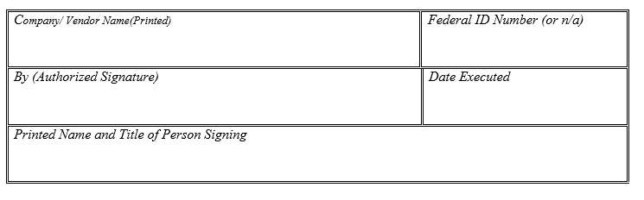

Attachment I
ECONOMIC SANCTIONS AGAINST RUSSIA
State of California
Office of the State Treasurer

On March 4, 2022, Governor Gavin Newsom issued Executive Order N-6-22 (EO) regarding the imposition of sanctions in response to Russian aggression in Ukraine. The EO is located at https://www.gov.ca.gov/wp-content/uploads/2022/03/3.4.22-Russia-Ukraine-Executive-Order.pdf.

The State Treasurer’s Office (STO) requires compliance with the economic sanctions set forth in the EO including, but not limited to, the federal executive orders identified in the EO and the sanctions identified on the U.S. Department of the Treasury website at https://home.treasury.gov/policy-issues/financial-sanctions/sanctions-programs-and-country-information/ukraine-russia-related-sanctions. Failure to comply may be grounds for rejection of the firm’s bid or proposal, and failure to maintain ongoing compliance may be grounds for termination of your firm’s engagement with the STO, at the sole discretion of the STO.

To comply with this requirement, please answer each question below by checking one of the responses (including additional information, if applicable) and insert your firm’s name and Federal ID Number (if available).

- Is your firm a target of Economic Sanctions? “Economic Sanctions” refers to sanctions imposed by the U.S. government in response to Russia’s actions in Ukraine.

Yes ☐ No ☐

- Is your firm, after due inquiry, knowingly conducting prohibited transactions with sanctioned individuals or entities?

Yes ☐ No ☐

If the response to either question is “Yes,” please attach a report to this form that specifies why your firm is not in compliance and what steps are being taken to comply.

CERTIFICATION

I, the official named below, certify that the foregoing is true and correct.

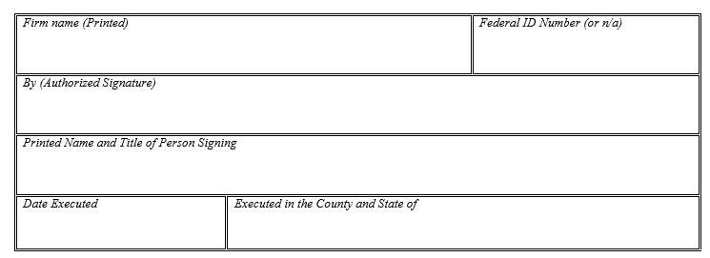

Attachment J

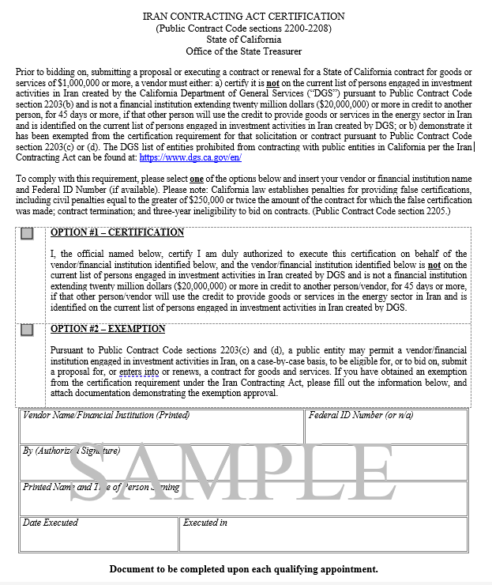
Attachment K

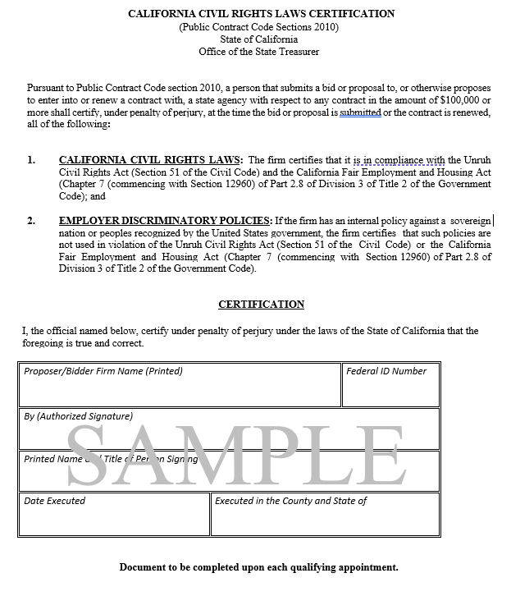

Attachment L

Minority Business Enterprise¹ and
Women’s Business Enterprise² Certification
State of California
Office of the State Treasurer

This form certifies the firm as a Minority Business Enterprise (MBE) or Women’s Business Enterprise (WBE) with the California State Treasurer’s Office. This certification is strictly voluntary³.

Instructions: Please answer all questions carefully. If a question does not apply to the firm or circumstances, please enter “N/A.”

- Firm Name
Headquarters Office Address
 | Street | City/State | Zip Code
Telephone Number(s):
 | (Area Code) Number | Email Address
California Office Address:
 | Street | City/State | Zip Code
California Phone:
 | (Area Code) Number | Email Address
- Name of Firm President / Chief Executive Officer / Managing Partner:
First Name | MI | Last Name | Title
- Name and Title of Person Completing this Application:
First Name | MI | Last Name | Title
- Certified Status Requested:
☐ Minority Business Enterprise (MBE)
☐ Women Business Enterprise (WBE)

¹ “Minority-owned” is a business at least 51% owned by one or more minority individuals, and whose management and daily operations are controlled by one or more minority individuals.
² “Women-owned” is a business at least 51% owned by one or more women, and whose management and daily business operations are controlled by one or more women.
³ Pursuant to California Constitution, Article 1, Section 31, the State shall not discriminate against, or grant preferential treatment to, any individual or group on the basis of race, sex, color, ethnicity, or national origin in the operation of public employment, public education, or public contracting.

